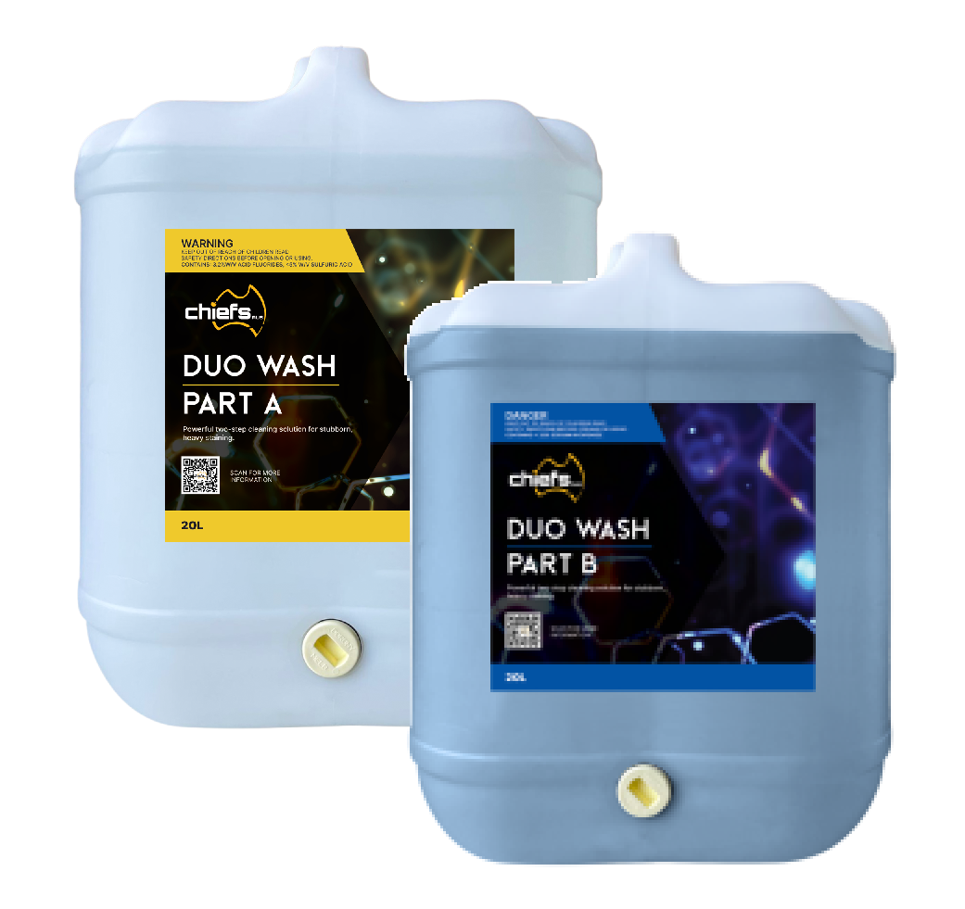**CHIEFS AUSTRALIA’S DUO WASH** is a two-part cleaning system for the removal of

long-term stains, and the iron oxide staining caused by Australian red dirt.

Duo Wash ‘Part A’ is foamed onto the vehicle with ‘Part B’ (recommended to be **Carnet Jumbo** or **Active Diamond**) then applied DIRECTLY over ‘Part A’.

The chemical reaction between Part A (low-Ph / acidic) and Part B (high-pH /alkaline / base) lifts heavy staining.

**If used correctly, the resultant runoff will be PH neutral; however, these products should NEVER be used where they could enter any waterways. Before use, consult with the local council about all legislative requirements.**

# **CHEMICAL INFORMATION** can be found on the product Safety Data Sheets, available from the supplier / manufacturer.

**SCAN HERE for SDS info**

SAFETY INFORMATION

**ALL CHIEFS AUSTRALIA PRODUCTS MUST BE USED IN STRICT COMPLIANCE WITH APPLICABLE LAWS, REGULATIONS AND SAFETY GUIDELINES**

* **PART A – Dangerous Good: Corrosive Liquid.**
* **PART B – Not considered a Dangerous Good, Corrosive Liquid.**
* **Users must be trained in the safe use and handling of these products & understand the risks of misuse.**
* 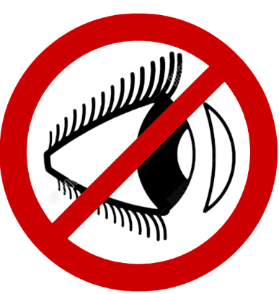The reading and understanding of product Safety Data Sheets (SDS) is required before use.
* Avoid contact with skin and eyes, and DO NOT INHALE. Do not wear soaked clothing.
* 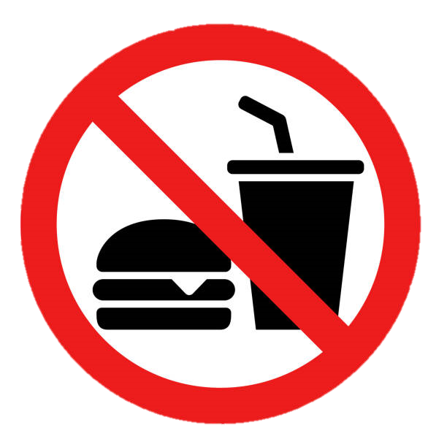Wash any contaminated clothing separately.
* Wearing contact lenses is to be avoided
* 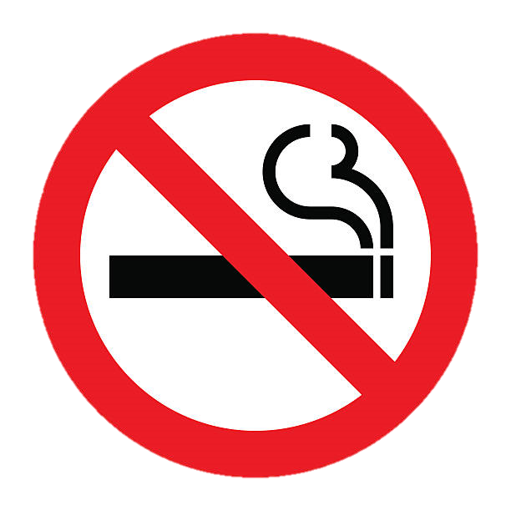Do not eat, drink, or smoke while handling
* Always wash hands with soap and water after handling.
* Products must not be allowed to enter waterways. Have a chemical spill kit on hand.
* Disposal of used, expired, spilled product must comply with manufacturer's recommendations.
* Storage of products must comply with legal requirements and manufacturer's recommendations.
* The following Personal Protective Equipment (PPE) should be worn during handling and use.

**Mandatory/Minimum Also Recommended**

**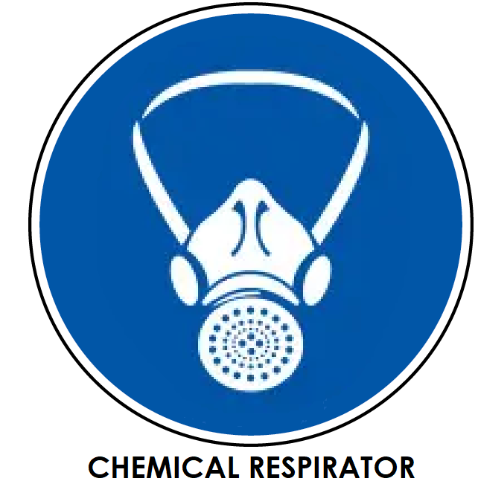

DEMONSTRATION OF SAFE USE

* Instruction video supplied by Australian importer – Chiefs Australia

SCAN HERE for HOW TO USE video

**TRAILER MOUNTED DELIVERY METHOD**

## **Quad Chemical Injection System** & Honda pressure washer

## Suitable for Duo Wash Part A, Part B

## plus 2 other stand alone cleaning products.

# TRAILER HITCH UP

* Ensure tow vehicle has correct capacity for the trailer’s weight (**including water weight**) ❑
* Ensure tow vehicle has correct round, 7 pin light connector port. ❑
* Ensure trailer coupler has correctly engaged with the vehicle’s tow ball. ❑
* Ensure coupler handle is in the lowest position and safety pin has been inserted. ❑
* Connect safety chains (a cris-cross formation) to the tow vehicle with rated shackles. ❑
* Connect trailer light connector lead to vehicle port and test all trailer lights. ❑
* Release trailer handbrake. ❑
* Swing up jockey wheel. ❑
* Conduct a walk-around inspection of the trailer to ensure all components are secure and present.
  + Pressure cleaner and water tank are securely mounted ❑
  + Hoses, fittings and wand have no visible damage or leaks ❑
  + Pressure cleaner fuel tank is full ❑
  + 20L chemical containers have been installed from their storage location and ensure each container is connected to its designated inlet port on chemical injection system. ❑
  + All required/recommended PPE is ready for use. ❑
  + First aid supplies are ready for use. ❑
* Fill water tank from filling station or other source, or ensure suitable hose and connections are   
  onboard if onsite water is available. ❑

# ARRIVING TO SITE

* Conduct a risk assessment to decide on a suitable location for use (ensuing NO product run   
  off may enter a waterway ❑
* Identify any hazards or concerns at this location. ❑
* Implement safety controls to make any identified hazards safer. ❑

# TRAILER SET UP

* Select suitable parking area (flat, stable ground without obstacles). ❑
* Position trailer, ensuring ample space around trailer to be able to conduct work required. ❑  
  If trailer is to be unhitched from tow vehicle, complete steps in ‘Trailer Hitch Up’, **in reverse**.
* Ensure trailer is level. ❑
* Consider using wheel chocks.

# SAFETY PREPARATIONS

* Review First Aid procedures ❑
* Ensure chemical spill kit is easily accessible, ready for use. ❑
* **Don all PPE. Maintain minimum contact with chemical spray or chemical run off.** ❑

# PRESSURE CLEANER STARTUP & PREP

* Move choke lever to the ‘choke’ position if engine is cold, or leave chock in ‘run’ position if hot. ❑
* Pull recoil starter gently until resistance is felt, then give a strong, smooth pull to start engine. ❑
* Gradually move the choke leaver to the ‘run’ position, if not already in this position. ❑
* Allow engine to warm up for a few minutes before using pressure cleaner. ❑
* Adjust ball valve on water tank to select correct water source; left for tank,   
  right for hose connection. ❑
* Release trigger lock and engage to run water through the cleaner before introducing chemicals. ❑
* Ensure chemical injection system is set to Part A. ❑

# CLEANING

* Check wind direction; Try to always have the wind to your back when positioning yourself. ❑
* Ensure people present/nearby know you are using chemicals with health hazards.   
  Ensure they are either at a distance as to not be affected by chemical spray or are wearing recommended PPE. ❑
* Wash off any loose build up. ❑

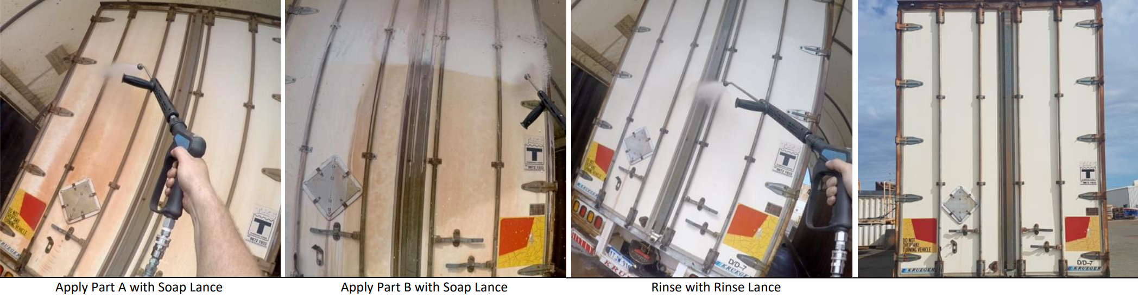**NOTE: If especially hot weather, clean the vehicle in sections, applying Part A, Part B and final rinse in manageable sections, working systematically (without letting products dry),, , before moving further down the vehicle.**

* Part A should be foamed onto a cool vehicle. Allow 2–5 minutes for penetration - ❑
* Switch chemical injection system to Part B. ❑
* Foam Part B **directly** over the top of Part A. ❑
* Switch chemical injection system to fresh water. ❑
* Wash down all areas with high pressure water **from bottom to top**, rinsing all surfaces   
  thoroughly to remove chemical residue, (making sure products do not enter waterways). ❑

# AFTER CLEANING

* Turn off engine switch, to shut down pressure cleaner.
* Release any pressure in pressure cleaner hose by engaging gun, then ensure trigger gun lock is on. ❑
* Close ball valve on water tank, depending on water source used (and disconnect and stow water hose if applicable). ❑
* Wind up pressure cleaner hose and place secure back on trailer, along with any other equipment. ❑
* Remove PPE and ensure no product has come into contact with skin / eyes. Apply first aid or seek medical assistance if required.
* Return PPE and any first aid supplies to storage location. ❑

# UPON TRAILER RETURN

* Park in suitable location and remove trailer from tow vehicle by completing steps from Section 6 - Trailer Hitch Up, **in reverse**. ❑
* Complete Return Inspection of trailer to ensure all items are present and in good condition. ❑

# CHEMICAL RETURN *(Hosepower staff only)*

* Don PPE – do not use wet PPE; obtain additional if required. ❑
* Remove chemicals from trailer and store Part A & Part B, and any other 20L chemicals housed on trailer, in a designated, well-ventilated area. ❑
* Wash / dry / replace any PPE requiring attention. ❑
* Return trailer to storage location. ❑

**HOSEPOWER**

**CUSTOMER ACKNOWLEDGEMENT FOR THE PURCHASE OF**

**CHIEFS AUSTRALIA PRODUCTS**

**General Notice:**

All products of Chiefs Australia must be used in strict compliance with applicable laws, regulations, and safety guidelines. Hosepower Pty Ltd does not accept liability for improper use, storage, or handling of these products.

**Local Council and Regulatory Compliance:**

Before use, the customer must check with local councils and relevant authorities regarding any specific requirements, restrictions, or regulations applicable to the use and disposal of these products. Compliance with all applicable environmental, health, and safety regulations is the sole responsibility of the customer.

**Safety Data Sheets (SDS):**

Safety Data Sheets (SDS) for all Chiefs Australia products are available upon request. The customer must review the SDS prior to use to ensure a full understanding of product hazards, handling precautions, and emergency procedures.

**Hazards and Safe Handling:**

All users must take all necessary precautions to prevent harm, including but not limited to:

* Ensuring adequate ventilation when using products containing volatile substances.
* Avoiding direct skin or eye contact with hazardous chemicals.
* Storing products in accordance with manufacturer recommendations.
* Disposing of used or expired products in compliance with local regulations.

**Personal Protective Equipment (PPE) Requirements:**

The customer and users of Chiefs Australia products must wear appropriate PPE when handling hazardous substances, as recommended in the SDS. Depending on the product, this may include:

* Safety glasses or face shields
* Chemical-resistant gloves
* Respiratory protection
* Protective clothing

Failure to wear appropriate PPE or follow safety guidelines may result in injury or health risks. Hosepower will not be liable for any damages, injuries, or non-compliance arising from improper use.

Upon purchase of a Chiefs Australia product, labelled with QR code, the customer, as an approved representative of their employer/business, acknowledges that they have had the opportunity to read, understood, and comply with all safety, handling, and regulatory requirements outlined in the provided documentation for the use of Chiefs Australia products, and will ensure these requirements are communicated to all other end users of these products within the business.

Customers are required to:

* check and comply with all relevant council and regulatory requirements for their purchased product.
* reviewed the applicable Safety Data Sheets (SDS) for their purchased product.
* understand the hazards associated with the purchased product and take appropriate precautions.
* ensure other end-users of purchased products are provided with the same information, and are trained in the use of the purchased product.
* ensure the use of all required Personal Protective Equipment (PPE)is used when handling purchased product.

Any questions about the purchased product should be directed to Hosepower Pty Ltd or Chiefs Australia Pty Ltd